

**Software Process And Quality Management**

**Team 5 K16T1**

**TEAM ASSIGNMENT**



|  |  |  |  |
| --- | --- | --- | --- |
| Date | Version | Author | Description |
| 20/10/2013 | 1.0 | Le Ngoc Chau | Create Document |
| 21/10/2013 | 1.1 | BigFiveTeam | Update Document |

**REVISIONS**

**CONTENTS**

1. Member Lists: 3

2. Introduction: 4

2.1. What is Six sigma? 4

2.2. History: 5

2.3. Why is Six sigma important? 7

2.4. Roles and responsibilities: 7

2.5. Area application: 11

2.6. Who use Six sigma? 13

2.7. How to calculate Six sigma? 14

3. How to implement: 15

3.1. DMAIC: 15

❖ **Define** 15

❖ **Measure** 15

❖ **Analyze** 16

❖ **Improve** 16

❖ **Control** 17

3.2. DMADV: 18

❖ **Define** 18

❖ **Measure:** 19

❖ **Analyze:** 19

❖ **Design:** 19

❖ **Verify:** 20

3.3. Difference between DMAIC and DMADV: 21

❖ How are DMAIC and DMADV Similar? 21

❖ How are DMAIC and DMADV Different? 21

❖ When Should DMAIC and DMADV Be Used? 22

3.4. Tool: 23

4. Strengths and weaknesses: 26

4.1. Strengths: 26

4.2. Weaknesses: 28

4.3. Opportunities: 29

4.4. Threats: 30

5. Certificates: 31

5.1. What is the Six sigma certificates? 31

5.2. Why need certificates? 31

5.3. How to get Six sigma certificates? 31

5.4. Six Sigma Certification 32

6. Difference: 35

6.1. Difference between CMMI, ITIL, COBIT, ISO and Six sigma: 35

6.2. Six sigma related to Lean, TQM, TOC 37

❖ Six sigma and lean 37

❖ Six sigma and TQM 37

❖ Six sigma and TOC 38

7. Reference: 41

# Member Lists:

|  |  |
| --- | --- |
| T094054 | Trinh Thai Anh |
| T103573 | Le Ngoc Chau |
| T105026 | Khau Thanh Dao |
| T104898 | Huynh Trong Khang |
| T101184 | Ta Ngoc Thien Phu |
| T103569 | Nguyen Hoang Fa Thu |

# Introduction:

## What is Six sigma?

* In statistics and probability theory, the standard deviation (represented by the Greek letter sigma, σ) shows how much variation or dispersion from the average exists. A low standard deviation indicates that the data points tend to be very close to the mean (also called expected value); a high standard deviation indicates that the data points are spread out over a large range of values.
* Six Sigma is a management philosophy developed by Motorola that emphasizes setting extremely high objectives, collecting data, and analyzing results to a fine degree as a way to reduce defects in products and services. The central idea behind Six Sigma is that if you can measure how many “defects” you have in a process, you can systematically figure out how to eliminate them and get as close to “zero defects” as possible.
* We think about Six Sigma at three different levels:
* As a metric
* As a methodology
* As a management system
* Essentially, Six Sigma is lots of different things because it had different meanings over time, and also because it is now interpreted in increasingly different ways. At many organizations it simply means a measure of quality that strives for near perfection, so Six Sigma is still evolving.
* To achieve Six Sigma quality, a process must produce no more than 3.4 defects per million opportunities. An “opportunity” is defined as a chance for nonconformance, or not meeting the required specifications. This means we need to be nearly flawless in executing our key processes. Six Sigma is a vision we strive toward and a philosophy that is part of our business culture. Six Sigma revolves around a few key concepts:
* Critical to Quality: Attributes most important to the customer
* Defect: Failing to deliver what the customer wants
* Process Capability: What your process can deliver
* Variation: What the customer sees and feels
* Stable Operations: Ensuring consistent, predictable processes to improve what the customer sees and feels
* Design for Six Sigma: Designing to meet customer needs and process capability.

## History:

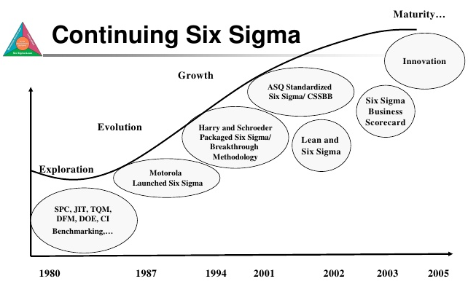

* The roots of Six Sigma as a measurement standard can be traced back to Carl Frederick Gauss (1777-1855) who introduced the concept of the normal curve. Six Sigma as a measurement standard in product variation can be traced back to the 1920′s when Walter Shewhart showed that three sigma from the mean is the point where a process requires correction. Many measurement standards (Cpk, Zero Defects, etc.) later came on the scene but credit for coining the term “Six Sigma” goes to a Motorola engineer named Bill Smith. (Incidentally, “Six Sigma” is a federally registered trademark of Motorola).
* In the early and mid-1980s with Chairman Bob Galvin at the helm, Motorola engineers decided that the traditional quality levels — measuring defects in thousands of opportunities – didn’t provide enough granularity. Instead, they wanted to measure the defects per million opportunities. Motorola developed this new standard and created the methodology and needed cultural change associated with it. Six Sigma helped Motorola realize powerful bottom-line results in their organization – in fact, they documented more than $16 Billion in savings as a result of our Six Sigma efforts.
* Since then, hundreds of companies around the world have adopted Six Sigma as a way of doing business. This is a direct result of many of America’s leaders openly praising the benefits of Six Sigma. Leaders such as Larry Bossidy of Allied Signal (now Honeywell), and Jack Welch of General Electric Company. Rumor has it that Larry and Jack were playing golf one day and Jack bet Larry that he could implement Six Sigma faster and with greater results at GE than Larry did at Allied Signal. The results speak for themselves.
* Six Sigma has evolved over time. It’s more than just a quality system like TQM or ISO. It’s a way of doing business. As Geoff Tennant describes in his book Six Sigma: SPC and TQM in Manufacturing and Services: “Six Sigma is many things, and it would perhaps be easier to list all the things that Six Sigma quality is not. Six Sigma can be seen as: a vision; a philosophy; a symbol; a metric; a goal; a methodology.”

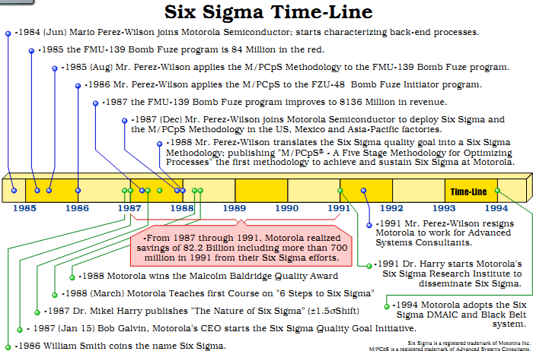

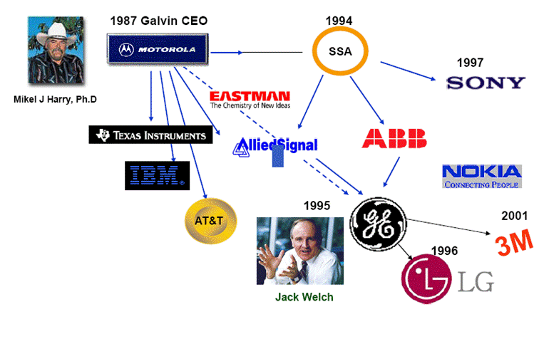

## Why is Six sigma important?

* There are three key elements of quality: customer, process and employee. Everything we do to remain quality focuses on these three essential elements:

|  |
| --- |
| Delighting Customers: Customers are the center of universe: they define quality. They expect performance, reliability, competitive prices, on-time delivery, service, clear and correct transaction processing and more. In every attribute that influences customer perception, we know that just being good is not enough. Delighting customers is a necessity. Because if we don’t do it, someone else will! |
| Processes Outside-In Thinking: Quality requires us to look at our business from the customer’s perspective, not ours. In other words, we must look at our processes from the outside-in. By understanding the transaction lifecycle from the customer’s needs and processes, we can discover what they are seeing and feeling. With this knowledge, we can identify areas where we can add significant value or improvement from their perspective. |
| Leadership Commitment: People create results. Involving all employees is essential to project quality approach. Project must be committed to providing opportunities and incentives for employees to focus their talents and energies on satisfying customers. |
| All employees are trained in the strategy, statistical tools and techniques of Six Sigma quality. |

* Six Sigma is valuable because it creates an environment for improving productivity and efficiency in a business environment of continuous improvement. It gives everyone an opportunity to make improvements to traditional processes. It creates a disciplined, knowledge-based approach designed to enhance customer satisfaction and build a customer culture that embraces innovative approaches to technology and business development. Overall, it is a highly structured strategy for acquiring, assessing and applying customer expectations with manageable solutions for the purposes of product, system or enterprise innovation and design.
* Most companies operate at three or Four Sigma. That means the losses they incur as a result of poor quality cost them 10 to 15 percent of their revenue. A company operating at Six Sigma. However, can generate considerable savings. According to one source, the savings as a percentage of revenue vary from 1.2 percent to 4.5 percent [source: I Six Sigma]. That means a company with revenues of $1 million could save up to $45,000, and a company with revenues of $1 billion could save up to $45,000,000.

## Roles and responsibilities:

* One key innovation of Six Sigma involves the absolute "professionalizing" of quality management functions. Prior to Six Sigma, quality management in practice was largely relegated to the production floor and to [statisticians](http://en.wikipedia.org/wiki/Statistician) in a separate quality department. Formal Six Sigma programs adopt a kind of elite ranking terminology (similar to some martial arts systems, like Kung-Fu and Judo) to define a hierarchy (and special career path) that kicks across all business functions and levels.
* Six Sigma identifies several key roles for its successful implementation.

|  |  |  |
| --- | --- | --- |
| Roles | Definition & Responsibilities | What do they do? |
| Executives | **I**ncludes the CEO and other members of top management. They are responsible for setting up a vision for Six Sigma implementation. They also empower the other role holders with the freedom and resources to explore new ideas for breakthrough improvements. | * The executives legitimize the changes about to happen * Establish the vision—why we are doing Six Sigma. * Articulate the business strategy—how Six Sigma supports the business strategy. * Provide resources. * Remove roadblocks and buffer conflicts. * Support the culture change by encouraging others to take the risk and make the change. * Monitor the results by defining the scorecard for Six Sigma and holding others accountable for the results. * Align the systems and structures with the changes taking place. * Participate with the black belts through project reviews and recognition of results. |
| Champions | Champions take responsibility for Six Sigma implementation across the organization in an integrated manner. The Executive Leadership draws them from upper management. Champions also act as mentors to Black Belts. | * An officially designated person who has primary responsibility for helping management plan and manage the change process * Develop a vision for the organization. * Create and maintain passion. * Develop a model for a perfect organization. * Facilitate the identification and prioritization of projects. * Develop the strategic decisions in the deployment of Six Sigma around timing and sequencing of manufacturing, transactional, and new product focus. * Extend project benefits to additional areas. * Communicate and market the breakthrough strategy process and results. * Share best practices. * Establish and monitor a team process for optimum results. * Recruit, inspire and "free up" black belts—pick the best people. * Develop the reward and recognition program for black belts. * Remove barriers for black belts. * Coach and develop black belts. * Provide the drum beat for results by reviewing projects and keeping score through metrics. * Develop a comprehensive training plan for implementing the breakthrough strategy. |
| Master black belt | Identified by champions, act as in-house coaches on Six Sigma. They devote 100% of their time to Six Sigma. They assist champions and guide Black Belts and Green Belts. Apart from statistical tasks, they spend their time on ensuring consistent application of Six Sigma across various functions and departments. | * Be the expert in the tools and concepts. * Develop and deliver training to various levels of the organization. * Certify the black belts with additional specialized skills or experience especially useful in deployment of Six Sigma across the enterprise * Assist in the identification of projects. * Coach and support the black belts in project work. * Participate in project reviews to offer technical expertise. * Collaborate with the champions. * Demonstrate passion around Six Sigma. * Share best practices. * Take on leadership of major programs. * Develop new tools or modify old tools for application. * Understand the link between Six Sigma and the business strategy. * Permanent full-time change agent |
| Black belt | Operate under Master Black Belts to apply Six Sigma methodology to specific projects. They devote 100% of their valued time to Six Sigma. They primarily focus on Six Sigma project execution and special leadership with special tasks, whereas Champions and Master Black Belts focus on identifying projects/functions for Six Sigma. | * Expert in leading project execution with relevant experience in one or more specific fields; extensive training and strong background in statistics and analysis. * Understand how to implement the breakthrough strategy application. * Prepare initial project assessment to validate benefits. * Lead and direct the team to execute projects. * Determine the most effective tools to apply. * Show the data. * Identify barriers. * Identify project resources. * Determine appropriate and applicable input from knowledgeable functional experts/team leaders/coaches. * Report progress to appropriate leadership levels. * Present the final report. * Deliver results on time. * Solicit help from the champions when needed. * Influence without direct authority. * Be a breakthrough strategy enthusiast. * Stimulate champion thinking. * Teach and coach breakthrough strategy methods and tools. * Manage project risk. * Ensure the results are sustained. * Document Learning. |
| Green Belt | Are the employees who take up Six Sigma implementation along with their other job responsibilities, operating under the guidance of Black Belts. | * who current positions are associated with the problem to be solved while performing their regular duties, familiar with basic statistical tools and less intensive in training * Six Sigma project originator * Six Sigma project leader * Part-time Six Sigma * Change agent. Continues to perform normal duties while participating on Six Sigma project teams * Six Sigma champion in local area |
| Yellow Belt (Team members) |  | * Provide the everyday requirements for execution of the DMAIC model. They also help spread the word about six sigma tools and processes and ultimately they become part of the reservoir of human resources available for future projects |
| White Belt (Process owner) |  | * This person takes on a new, cross-functional responsibility to manage all the steps that provide value to the internal as well as external customer. The sponsor and the process owner may be the same person. |

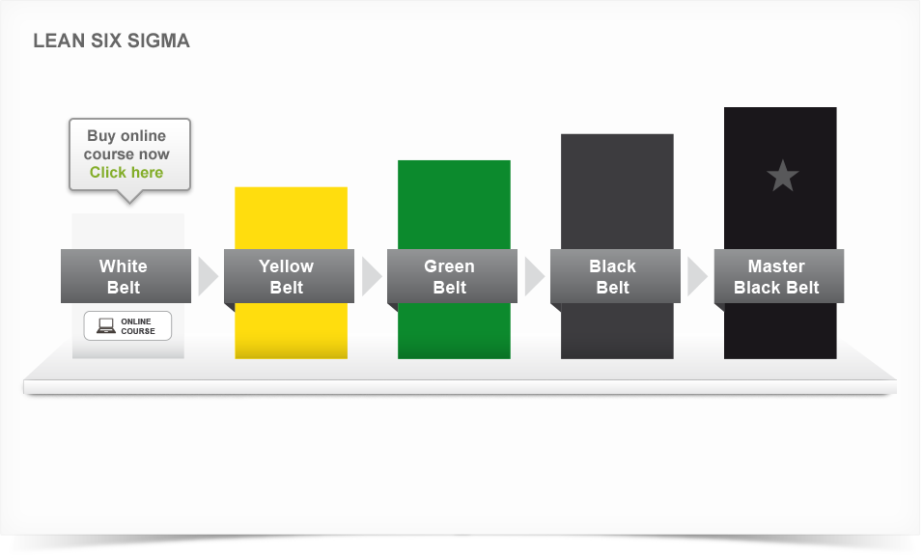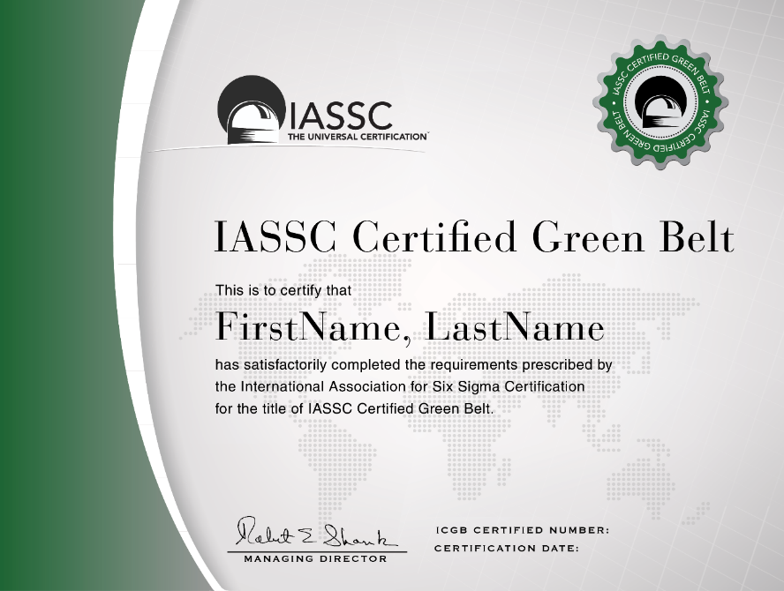

## Area application:

* Six Sigma is an “Industry Independent” methodology and has been successfully applied across:
* Manufacturing Industry including Auto motives, Aerospace, Health Equipment, FMCG, Electronic Goods, Continuous process Industries, Textiles, etc.
* Service Industry including Telecom, banking and Financial Services, Health Care, hotels, IT, ITES, KOPs, Airline, Cargo movement, Support Service, HR services, Marketing Service, etc.
* R&D organizations or in R&D function of various organizations for example:

|  |  |
| --- | --- |
| **Industry** | **Examples of Six Sigma Applicability** |
| Automotive | * Enhancing Supplier Quality * Improving Safety & Reliability of Finished Vehicles * Reducing Manufacturing defects at each stage * Using Design FMEA to understand and prevent any possible design failures * Reducing variation in all the critical parameters that impact the finished product * Improving the overall Incoming Material Quality or parts Quality * Optimizing Inventory levels for all major parts * Reducing time to manufacture * Reducing Design defects * Reducing Supplier Lead time i.e. the time take by each supplier to deliver goods * Improving First time yield and efficiency of each step in the Manufacturing assembly line. |
| Continuous Process Plants | * Improving overall Yield of each shift * Reduce scrap or spilled materials * Reduce the Process failures or breakdowns * Increase Plant capacity utilization * Improve Operator Productivity * Reduce time to restart the process after failure * Create mechanisms to prevent failures at each stage * Improve overall process stability & control |
| Engineering Parts Manufacturing | * Reduce Manufacturing cycle time (time of order to delivery) * Improve Customer Service performance scores * Reduce or optimize inventory levels * Reduce scrap or cost of poor quality * Reduce warranty costs * Reduce rejections due to design errors * Improve parts design process to meet specifications 100% of times * Improve parts reliability by identifying & optimizing critical factors that ensure reliability |
| Information Technology :Software development | * Reducing the overall Software development times * Reducing the number of errors found during product usage * Improving the estimation process to reduce time and cost overruns * Improving the requirements gathering process to reduce rework * Reducing complaints resolution time * Creating systems to detect defects early in the process (to reduce high costs associated with defects identified later) * Reducing appraisal cost per defect by phase and appraisal type (by project and in total) * Reducing rework (All work done to fix an application after it has been delivered to a customer is rework. This includes corrections to features or functions that are incorrect, and also may include "missed requirements" - things the customer expected but did not receive. |
| Telecom | * Improving ARPU (Average revenue per unit) * Reducing Billing errors * Reducing timeliness of billing * Improving the Call Completion rate (i.e Network Quality) * Reducing network congestion * Development of new features, processes for new services * Improving accuracy, timeliness and completeness of new connections * Improving accuracy, timeliness and completeness of customer communication. * Reducing Customer churn * Reducing network congestion * Improving call routing procedures * Improving sales productivity |
| R&D/ Product Design | * Reducing the time to market * Reducing rework through synergy between R&D and the customer facing staff. * Improving the overall performance & quality of product from start * Minimizing product failures by ensuring robust designs * Improving quality of research process & experiments by providing mass education in Experimental design and Multivariate studies * Improving quality of design reviews (data driven reviews) * Reducing defects in final product thereby saving on warranty costs. |

## Who use Six sigma?



* In the early days, Six Sigma was limited to complex manufacturing environments. But today, it has spread into every industry and into every functional area. According to a survey conducted by Quality
* Digest, the distribution of Six Sigma programs is now spread across a growing number of functional areas:
* Manufacturing
* Engineering
* Administration
* Test/Inspection
* Plant operation
* Customer service
* Research/Development
* Purchasing
* Sales/Marketing
* Shipping/Receiving
* Document control
* Pollution prevention
* Still, it’s not right for every company or every process. Many small companies simply lack the resources necessary to implement Six Sigma. And others with the financial resources sometimes don’t have enough support from upper management to get Six Sigma initiatives off the ground.



## How to calculate Six sigma?

* To give such numbers meaning, the engineers at Motorola set up a scale to evaluate the quality of a process based on these defect calculations. At the top of the scale is Six Sigma, which equates to 3.4 DPMO, or 99.9997% defect-free. In other words, if you have a process running at Six Sigma, you've almost eliminated all defects -- it's nearly perfect. Of course, most processes don't run at Six Sigma. They run at Five Sigma, Four Sigma or worse. Here's the full scale to get an appreciation of the numbers involved:

DPMO = \frac{1,000,000 \times \mbox{number of defects}}{\mbox{number of units} \times \mbox{number of opportunities per unit}}

* **Five Sigma** = 233 DPMO, or 99.98% defect-free
* **Four Sigma** = 6,210 DPMO, or 99.4% defect-free
* **Three Sigma** = 66,807 DPMO, or 93.3% defect-free
* **Two Sigma** = 308,538 DPMO, or 69.1% defect-free
* **One Sigma** = 691,462 DPMO, or 30.9% defect-free
* Indeed, as Six Sigma has evolved, it has become closely associated with other business strategy methodologies, such as Balanced Scorecard. That means different people at different times will define Six Sigma quite differently. Some will describe it as a metric, or a measurement of defects. Others will describe it as a methodology, a way to solve problems.

|  |  |  |  |
| --- | --- | --- | --- |
| Sigma level | [DPMO](http://en.wikipedia.org/wiki/Defects_per_million_opportunities) | Percent defective | Percentage yield |
| 1 | 691,462 | 69% | 31% |
| 2 | 308,538 | 31% | 69% |
| 3 | 66,807 | 6.7% | 93.3% |
| 4 | 6,210 | 0.62% | 99.38% |
| 5 | 233 | 0.023% | 99.977% |
| 6 | **3.4** | **0.00034%** | **99.99966%** |
| 7 | 0.019 | 0.0000019% | 99.9999981% |

# How to implement:

## DMAIC:

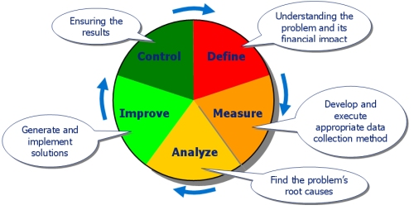

* **Define**

|  |  |
| --- | --- |
| Goals | The purpose of this step is to clearly articulate the business problem, goal, potential resources, project scope and high-level project timeline. This information is typically captured within project charter document. Write down what you currently know. Seek to clarify facts, set objectives and form the project team. |
| Output | * + - A clear statement of the intended improvement and how it is to be measured     - A high-level map of the process     - A list of what is important to the customer |
| Do | * + - Define customer requirements as they relate to this project. Explicit customer requirements are called Critical-to-Quality (CTQ) characteristics;     - Develop defect definitions as precisely as possible;     - Perform a baseline study (a general measure of the level of performance before the improvement project commences)     - Create a team charter and Champion;     - Estimate the financial impact of the problem     - Obtain senior management approval of the project |

* **Measure**

|  |  |
| --- | --- |
| Goals | The purpose of the Measure phase is to fully understand the current performance by identifying how to best measure current performance and to start measuring it. The measurements used should be useful and relevant to identifying and measuring the source of variation. Focus the improvement effort by gathering information on the current situation |
| Output | * + - Data that pinpoints problem location or occurrence     - Baseline data on current process sigma     - A more focused problem statement |
| Do | * + - Identify the specific performance requirements of relevant Critical-to-Quality (CTQ) characteristics     - Map relevant processes with identified Inputs and Outputs so that at each process step, the relevant Outputs and all the potential Inputs (X) that might impact each Output are connected to each other     - Generate list of potential measurements     - Analyze measurement system capability and establish process capability baseline     - Identify where errors in measurements can occur     - Start measuring the inputs, processes and outputs and collecting the data     - Validate that the problem exists based on the measurements     - Refine the problem or objective (from the Analysis phase) |

* **Analyze**

|  |  |
| --- | --- |
| Goals | In the Analyze phase, the measurements collected in the Measure phase are analyzed so that hypotheses about the root causes of variations in the measurements can be generated and the hypothesis subsequently validated. It is at this stage that practical business problems are turned into statistical problems and analyzed as statistical problems |
| Output | * + - A theory that has been tested and confirmed |
| Do | * + - Generate hypotheses about possible root causes of variation and potential critical Inputs (X’s);     - Identify the vital few root causes and critical inputs that have the most significant impact     - Validate these hypotheses by performing Multivariate analysis. |

* **Improve**

|  |  |
| --- | --- |
| Goals | * + - The purpose of this step is to identify, test and implement a solution to the problem; in part or in whole. Identify creative solutions to eliminate the key root causes in order to fix and prevent process problems. Use brainstorming or techniques like [Six Thinking Hats](http://en.wikipedia.org/wiki/Six_Thinking_Hats) and [Random Word](http://en.wikipedia.org/wiki/Random_stimulus). Some projects can utilize complex analysis tools like DOE ([Design of Experiments](http://en.wikipedia.org/wiki/Design_of_Experiments)), but try to focus on obvious solutions if these are apparent. |
| Output | * + - Identification of planned, tested actions that should eliminate or reduce the impact of the identified root causes |
| Do | * + - Identify ways to remove causes of variation;     - Verify critical Inputs;     - Discover relationships between variables;     - Establish operating tolerances which are the upper and lower specification limits (the engineering or customer requirement) of a process for judging acceptability of a particular characteristic, and if strictly followed will result in defect-free products or services;     - Optimize critical Inputs or reconfigure the relevant process. |

* **Control**

|  |  |
| --- | --- |
| Goals | The purpose of this step is to sustain the gains. Monitor the improvements to ensure continued and sustainable success. Create a control plan. Update documents, business process and training records as required  A [Control chart](http://en.wikipedia.org/wiki/Control_chart) can be useful during the control stage to assess the stability of the improvements over time |
| Output | * + - Before-and-After analysis     - Monitoring system     - Completed documentation of results, learning , and recommendations |
| Do | * + - Validate measurement systems;     - Verify process long-term capability;     - Implement process control with control plan to ensure that the same problems don’t reoccur by continually monitoring the processes that create the products or services. |

## DMADV:

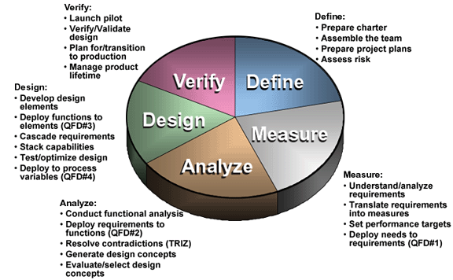

The acronym DMADV sounds pretty much similar to DMAIC. The similarity ends after the first three letters DMA

* **Define:** You will define the goals of the project and that of the customers (both internal and external)

|  |  |
| --- | --- |
| Goals | * The purpose of this step is to clearly articulate the business problem, goal, potential resources, project scope and high-level project timeline. This information is typically captured within project charter document. Write down what you currently know. Seek to clarify facts set objectives and form the project team. Define the following: |
| Output | * + - A clear statement of the intended improvement and how it is to be measured     - A high-level map of the process     - A list of what is important to the customer |
| Do | * + - Define customer requirements as they relate to this project. Explicit customer requirements are called Critical-to-Quality (CTQ) characteristics;     - Develop defect definitions as precisely as possible;     - Perform a baseline study (a general measure of the level of performance before the improvement project commences)     - Create a team charter and Champion;     - Estimate the financial impact of the problem   Obtain senior management approval of the project |

* **Measure:** Here you will quantify the customer needs as well as the goals of the management

|  |  |
| --- | --- |
| Goals | * The purpose of the Measure phase is to fully understand the current performance by identifying how to best measure current performance and to start measuring it. The measurements used should be useful and relevant to identifying and measuring the source of variation. Focus the improvement effort by gathering information on the current situation |
| Output | * + - Data that pinpoints problem location or occurrence     - Baseline data on current process sigma     - A more focused problem statement |
| Do | * + - Identify the specific performance requirements of relevant Critical-to-Quality (CTQ) characteristics     - Map relevant processes with identified Inputs and Outputs so that at each process step, the relevant Outputs and all the potential Inputs (X) that might impact each Output are connected to each other     - Generate list of potential measurements     - Analyze measurement system capability and establish process capability baseline     - Identify where errors in measurements can occur     - Start measuring the inputs, processes and outputs and collecting the data     - Validate that the problem exists based on the measurements     - Refine the problem or objective (from the Analysis phase) |

* **Analyze:** Analyze the options, existing process to determine the cause of error origination and evaluate corrective measures

|  |  |
| --- | --- |
| Goals | * In the Analyze phase, the measurements collected in the Measure phase are analyzed so that hypotheses about the root causes of variations in the measurements can be generated and the hypothesis subsequently validated. It is at this stage that practical business problems are turned into statistical problems and analyzed as statistical problems |
| Output | * + - A theory that has been tested and confirmed |
| Do | * + - Generate hypotheses about possible root causes of variation and potential critical Inputs (X’s);     - Identify the vital few root causes and critical inputs that have the most significant impact     - Validate these hypotheses by performing Multivariate analysis. |

### **Design:**

|  |  |
| --- | --- |
| Goals | * The purpose of this step design a new process or a corrective step to the existing one to eliminate the error origination that meets the target specification |
| Output | * New process is designed |
| Do | * Develop design elements * Deploy function to elements * Cascade requirement * Stack capabilities * Test/optimize design * Deploy to process variables |

### **Verify:**

|  |  |
| --- | --- |
| Goals | * The purpose of this step is verify, by simulation or otherwise, the performance of thus developed design and its ability to meet the target needs |
| Output | Result of verify that the process designed works fine and is able to meet the target. Once the results are positive, the process is implemented and handed over to the customer. |
| Do | * Launch pilot * Verify/Validate design * Plan for/transition to production * Manage product lifetime |

## Difference between DMAIC and DMADV:

### How are DMAIC and DMADV Similar?

* Six Sigma methodologies used to drive defects to less than 3.4 per million opportunities
* Data intensive solution approaches. Intuition has no place in Six Sigma
* Implemented by Green Belts, Black Belts, Master Black Belts
* Way to help meet the business / financial bottom-line number
* Implemented with the support of champion and process owner

### **How are DMAIC and DMADV Different?**

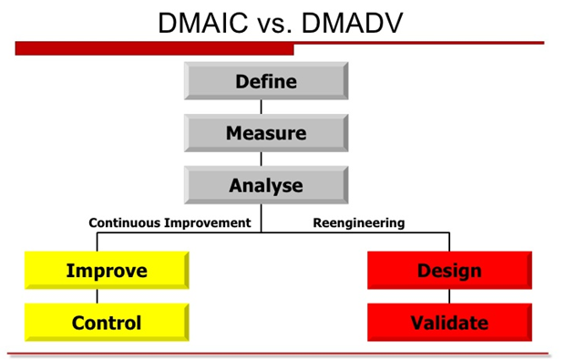

* DMAIC concentrates on making improvements to a business process in order to reduce or eliminate defects; DMADV develops an appropriate business model destined to meet the customers’ requirements.
* Despite the shared first three letters of their names, there are some notable differences between them.  The main difference exists in the way the final two steps of the process are handled.  With DMADV, the Design and Verify steps deal with redesigning a process to match customer needs, as opposed to the Improve and Control steps that focus on determining ways to readjust and control the process.   DMAIC typically defines a business process and how applicable it is; DMADV defines the needs of the customer as they relate to a service or product.
* With regards to measurement, DMAIC measures current performance of a process while DMADV measures customer specifications and needs.

### **When Should DMAIC and DMADV Be Used?**

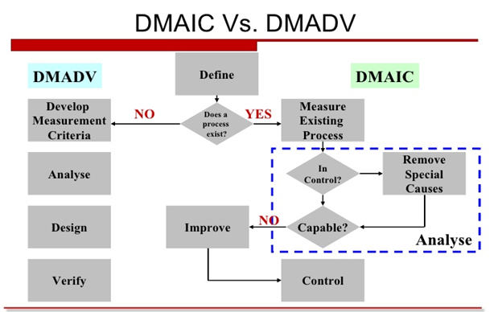

|  |  |
| --- | --- |
| When to use DMAIC | When to use DMADV |
| Used when a product or process is in existence and is not meeting customer specification or is not performing adequately | A product or process is not existence and one needs to be developed  The existence product or process exist and has been optimized and still doesn’t meet the level of customer specification or six sigma level |

## Tool:

|  |  |  |
| --- | --- | --- |
| Project Phase | Candidate Six Sigma Tools | Six Sigma Tools |
| Define | * Project charter * VOC tools (surveys, focus groups, letters, comment cards) * Process map * QFD * SIPOC * Benchmarking * Project planning and management tools * Pareto analysis | * **Project charter** this document is intended to clearly describe problems, defect definitions, team information and deliverables for a proposed project and to obtain agreement from key stakeholders. * **Trend Chart** - to see (visually) the trend of defect occurrence over a period of time. * **VOC tools (surveys, focus groups, letters, comment cards)** * **Process map** * **QFD** * **SIPOC** * **Benchmarking** * **Project planning and management tools** * **Pareto analysis** to see (visually) how critical each input is in contributing negatively or positively to total output or defects. |
| Measure | * Measurement systems analysis * Process behavior charts (SPC) * Exploratory data analysis * Descriptive statistics * Data mining * Run charts * Pareto analysis | * **Fishbone Diagram** – to demonstrate the relationships between inputs and outputs * **Process Mapping** - to understand the current processes and enable the team to define the hidden causes of waste. * **Cause & Effect Matrix** - to quantify how significant each input is for causing variation of outputs. * **Preliminary Failure Mode & Effect Analysis (FMEA)** - using this in the Measure phase helps to identify and implement obvious fixes in order to reduce defects and save costs as soon as possible. * **Gauge Repeatability & Reproducibility (GR&R**) - used to analyze the variation of components of measurement systems so minimize any unreliability in the measurement systems. |
| Analyze | * Cause-and-effect diagrams * Tree diagrams * Brainstorming * Process behavior charts (SPC) * Process maps * Design of experiments * Enumerative statistics (hypothesis tests) * Inferential statistics (Xs and Ys) * Simulation | * **Five Why’s** - use this tool to understand the root causes of defects in a process or product, and to penetrate through incorrect assumptions about causes. * **Tests for normality (Descriptive Statistics, Histograms**) – this is used to determine if the collected data is normal or abnormal so as to be properly analyzed by other tools. * **Correlation/Regression Analysis** - to identify the relationship between process inputs and outputs or the correlation between two different sets of variables. * **Analysis of Variances (ANOVA)** - this is an inferential statistical technique designed to test for significance of the differences among two or more sample means. * **FMEA (Failure Mode and Effect Analysis**) - applying this tool on current processes enables identification of sufficient improvement actions to prevent defects from occurring. * **Hypothesis testing methods** - these are series of tests in order to identify sources of variability using historical or current data and to provide objective solutions to questions which are traditionally answered subjectively. |
| Improve | * Force field diagrams * FMEA * 7M tools * Project planning and management tools * Prototype and pilot studies * Simulations | * + - Force field diagrams     - FMEA     - 7M tools     - Project planning and management tools     - Prototype and pilot studies     - Simulations     - Process Mapping - this tool helps to represent the new process subsequent to the improvements.     - Process Capability Analysis (CPK) - in order to test the capability of process after improvement actions have been implemented to ensure we have obtained a real improvement in preventing defects.     - DOE (Design of Experiment) - This is a planned set of tests to define the optimum settings to obtain the desired output and validate improvements. |
| Control | * SPC * FMEA * ISO 900× * Change budgets, bid models, cost estimating models * Reporting system | * Control Plans -t his is a single document or set of documents that documents the actions, including schedules and responsibilities, that are needed to control the key process inputs variables at the optimal settings. * Operating Flow Chart(s) with Control Points - this is a single chart or series of charts that visually display the new operating processes. * Statistical Process Control (SPC) charts - these are charts that help to track processes by plotting data over time between lower and upper specification limits with a center line. * Check Sheets - this tool enables systematic recording and compilation of data from historical sources, or observations as they happen, so that patterns and trends can be clearly detected and shown. |

# Strengths and weaknesses:

## Strengths:

* **Customer focus**

Customer focus is the core of quality and the ultimate goal of any successful process. In a typical Six Sigma program for process improvement, the aim is to build what the customers want. Improvements are defined by their impact on customer satisfaction, achieved through the systematic framework and tools of Six Sigma.

* **Data-driven and statistical approach to problem solving**

A strong focus on technically sound quantitative approaches is the most important feature of Six Sigma. Six Sigma is firmly rooted in mathematics and statistics. Statistical tools are used systematically to measure, collect, analyze and interpret data and hence identify the directions and areas for process improvement. The once-popular quality program, total quality management (TQM), seemed to be little different from Six Sigma in the view of many quality practitioners who found both systems have much in common. However, Six Sigma adopts a systematic quantitative approach that overcomes the difficulties incurred by the general and abstract guide-lines in TQM; these guidelines could hardly be turned into a successful deployment strategy.

* **Top-down support and corporate-wide culture**

Six Sigma requires a top-down management approach. The initiative must come from top management and be driven through every level of the organization. It is not simply a matter of top management approving the budget for a Six Sigma implementation and expecting other levels simply to get on with it. In such a situation, the project would be doomed to failure from the start. With this top-down approach, a sense of ‘urgency’ will be felt by members of Six Sigma projects and their work will be taken more seriously.

* **Project-based approach**

Unlike systems such as TQM and Taguchi methods, Six Sigma is usually carried out on a project-by-project basis. The spirit is still the same -- continuous improvement –but the manifestation is different. With a project-based approach, a Six Sigma program can easily be identified and managed. A clear target must be specified in advance and examined to see whether a project should be carried out. Approved projects usually last between 4 and 6 months, and their performance is usually measured in terms of monetary returns.

* **Well-structured project team**

Associated with the project-based approach is a well-designed project team structure. A Six Sigma project team consists of Champions, Master Black Belts, Black Belts and Green Belts. The core of the operational Six Sigma team is made up of the Master Black Belts, Black Belts and Green Belts. Master Black Belts oversee Six Sigma projects and act as internal Six Sigma consultants for new initiatives. Black Belts are the core and full-time practitioners of Six Sigma. Their main purpose is to lead quality projects and work full-time until projects are completed. They are also responsible for coaching Green Belts, who are employees trained in Six Sigma but spend only a portion of their time completing projects while maintaining their regular work role and responsibilities. This clear and comprehensive team structure makes the program tangible and manageable.

* **Clear problem-solving framework**

Six Sigma provides a clear, systematic problem-solving framework, DMAIC, as the core of its technological base. Statistical tools, such as design of experiments, statistical process control and Monte Carlo simulations, and structured decision support tools, such as quality function deployment and failure mode and effects analysis, are integrated under this framework. The DMAIC approach has also been adopted for the service sector. This approach mainly focuses on combating variation, the main root cause of quality problems. In addition, the design for Six Sigma (DFSS) framework offers a systematic means to address quality problems from the design phase of any product. All these provide clear, unambiguous, continuous frameworks for practitioners.

* **Systematic human resource development**

Six Sigma emphasizes human resource development and calls for heavy investment in staff training. Practitioners of Six Sigma hold different titles such as Green Belt, Black Belt, Master Black Belt and Champion, which are related to the level of personal competency and roles in carrying out projects. Practitioners usually start from the more basic and applied Green Belt training. Then they proceed on to the next level of Black Belt to deal with problems in depth with more tools. Subsequently, their technical competencies will be elevated to those of Master Black Belt when they have gained the necessary technical and management experience for them to progress and effectively act as internal consultants to Six Sigma programs.

* **Project tied to bottom line**

As pointed out, Six Sigma is implemented on the basis of projects. Once the key business processes are identified, every project will have a deadline and be tied to the bottom line. There is usually an audit of the newly improved way of operating processes, thereby enabling the company to assess the actual effectiveness of each project.

## Weaknesses:

* **High investment**

A large amount of investment is required to train employees to be Green Belts, Black Belts, Master Black Belts and soon. It is generally recommended that an average of one Black Belt be available per 100 employees.

Thus an organization of 10000 employees would probably need to train 100 Black Belts. Returns from Six Sigma may not be realized in the short term. There may be negative returns at first. Hence, companies wishing to embark on Six Sigma projects will have to master the philosophy adopt the perspectives and maintain their commitment for an extended period. Because of this it may be difficult to justify the initial costs to stakeholders who have yet to see concrete results.

* **Highly dependent on corporate culture**

The success of any Six Sigma implementation is very much dependent on the flexibility of the organization in being able to adapt its established functions and processes to the structured and disciplined Six Sigma approach. Six Sigma is not just a technically sound program with a strong emphasis on statistical tools and techniques, but also requires the establishment of a strong management framework. In comparison with TQM models, Six Sigma places more emphasis on successful management elements. Thus a shift in the corporate culture within the organization is usually a necessity. This entails a shift in the internalized values and beliefs of the organization, ultimately leading to changes in internal behaviors and practices. This implies that if the company has an established and strongly traditional approach in its operations, changes are more difficult to carry out.

* **No uniformly accepted standards**

There is as yet no general body for the certification of Six Sigma personnel or companies, though there are many diverse organizations issuing Six Sigma certificates. No unified standards and procedures have been set up and accepted so far. For companies considering building up a core Six Sigma expertise, the lack of a standardized body of knowledge and a governing body to administer them may result in varying levels of competency amongst so-called ‘certified ‘Six Sigma practitioners. Every training organization determines its own training course content. Many of these training courses may be unbalanced in their focus or lack some critical methodological elements

## Opportunities:

* **Highly competitive market and demanding customers**

The current globalization and free trade agreements make the competition for market share more intense. Manufacturers are not competing locally or regionally, but globally. To gain or maintain one’s market share requires much more effort and endeavor than ever before. Higher quality and reliability are no longer a conscious choice of the organization but a requirement of the market. For any organization to be successful, quality and reliability in the products that they offer have become one of the essential competing elements. This offers a great opportunity for Six Sigma since the essence of Six Sigma is to achieve higher quality and reliability continuously and systematically.

* **Fast development of information and data mining technologies**

Six Sigma depends heavily on data. Data measurement, collection, analysis, summarization and interpretation constitute the foundation of Six Sigma technology. Accordingly, data manipulation and analysis techniques play an important role in Six Sigma. Advanced information technology and data mining techniques greatly enhance the applicability of Six Sigma because modern technologies make data analysis no longer a complicated, tedious task. The availability of user friendly software packages is certainly a good opportunity for the application of Six Sigma as it removes the psychological as well as operational hurdles of statistical analysis required in Six Sigma.

* **Growing research interest in quality and reliability engineering**

The growing interest in quality and reliability engineering research represents an-other opportunity for Six Sigma. For example, research in robust design combined with Six Sigma produces an important improvement to Six Sigma -- DFSS. While the traditional DMAIC approach mainly deals with existing processes, the more recent DFSS addresses issues mainly at the design stage; it introduces the idea of designing a process with Six Sigma capability, instead of transforming an existing process to Six Sigma capability. Interest in quality and reliability engineering research is growing and there is considerable potential for the improvement of Six Sigma.

* **Previous implementation of quality programs has laid foundation for the easy adoption of Six Sigma**

Modern quality awareness started in the mid-twentieth century. Since then, various quality programs have been developed and put in practice. These programs have laid a much needed foundation for the adoption of Six Sigma. Among these is TQM, which shares some similarities with Six Sigma, such as a focus on customer satisfaction and continuous improvement. Companies which have already implemented other quality programs generally find it less difficult to adopt Six Sigma, their previous experience serving as a valuable ‘warm-up’ exercise.

## Threats:

* Resistance to change

The success of Six Sigma requires cultural change within the organization.

Six Sigma should be embraced in the organization as a corporate philosophy rather than as‘ yet another’ quality initiative. Six Sigma revolutionized the way organizations work by introducing a new set of paradigms. Although Six Sigma tools are not difficult to learn, the managers and the rest of the work force who have been with the organization for a long time might view them as an additional burden. These managers rely mainly on their experience in dealing with problems and are confident enough to use their intuition rather than resort to statistical tools deriving information from available data. Such an attitude may be harmful to the success of Six Sigma. The middle managers and supervisors who have experienced many other quality initiatives may regard Six Sigma as yet another transient offering that will pass in due course.

* Highly competitive job market

Few companies practice lifelong employment in today’s competitive job market. This is even more prevalent given the rapidly changing economic, social and technological environment. People tend to change jobs more frequently, whether it be in pursuit of ‘better prospects’ or involuntarily. The impact of frequent job changing is further worsened by the fact that appreciable benefits from serious Six Sigma work can only be felt a few years after projects have been initiated. Corporate leadership plays a vital role in the successful implementation of Six Sigma. The implementation structure of Six Sigma demands strong support from the Champions or executive management.

Any changes in the executive management will have adverse effects on the implementation. With hostile market conditions, corporate leadership has become relatively more volatile. Chief executives are changed frequently, or changes may be brought about through mergers and acquisitions between organizations. When higher level management is changed frequently, it may be difficult to maintain the same level of top-down commitment to Six Sigma initiatives.

* Cyclical economic conditions

Economic trends are usually cyclical. In good times, companies may be more willing to invest additional income on process improvement efforts. This tendency may be reversed during situations of economic down turn as companies struggle to keep afloat. Such situations may be unhealthy for Six Sigma implementation, again particularly in view of the fact that an extended training and application phase is often needed before significant financial gains can be seen.

# Certificates:

## What is the Six sigma certificates?

Six Sigma certification is a confirmation of an individual’s capabilities with respect to specific competencies. Just like any other quality certification, however, it does not indicate that an individual is capable of unlimited process improvement – just that they have completed the necessary requirements from the company granting the certification

## Why need certificates?

The reasons for certification are the same for any other certification:

* To display proficiency in the subject matter
* To increase desirability by employers
* To potentially increase your salary

Ultimately, certification is a professional decision that can only be made by you. In some cases, it will be required for you to advance within an organization. For instance, at some companies it is a requirement of every salaried employee to be Green Belt trained and certified if they want to be promoted within the organization. In other cases, Six Sigma certification will display your energy and intent to be a leader within the quality profession.

## How to get Six sigma certificates?

**Instructions:**

*1.* Determine which level of Six Sigma certification you are seeking. Both Green Belt and Black Belt certifications are available, with the latter requiring a greater commitment and level of skill.

*2.* Obtain Six Sigma training. If you have not yet completed a training program for the level of certification you are seeking, you will need to devote substantial time and effort to learning Six Sigma methodology, project management techniques and data analysis tools.

[ACCA Course in London](http://www.googleadservices.com/pagead/aclk?sa=L&ai=C_6YZeEFWUvvAF4e4ige8s4CYBpDxhOUDyI7czmeQn6C6TRABIKmJrQZQ8JPOkwZgwbX6DaABgNHh1QPIAQGpAoIS3lblv7o-qAMBqgSOAU_QpL9af71QObu5AafiSuK7W3LFkaw3lVxFvLQ2lZzFk23nJTEyQQnBRpOCzUK8lp3ytjAXeGlzIL9PLBY3zhot9A1avVDHSLWfgF2050IqiEU-65NXAR1ZFle0wkEDW0SWHrDvXZswqGtj1UzSx9g8w0SgkQSevxik9vw6nNAlWM3FitiBTDULKfNRKvCIBgGAB-iunio&num=1&cid=5Gj9AfFcPrVgW1utNM62hE82&sig=AOD64_0Od9ur1omLsvbEDzVgi3xzksOT1A&client=ca-ehow_300x250&adurl=http://www.lsbf.org.uk/acca.html%3Futm_source%3Dgoogle%26utm_medium%3Dcpc%26utm_campaign%3Dacca-vietnam-display-text)

Learn from Award-winning Tutors! Free Financial Skills Certificates.

[www.LSBF.org.uk/ACCA](http://www.googleadservices.com/pagead/aclk?sa=L&ai=C_6YZeEFWUvvAF4e4ige8s4CYBpDxhOUDyI7czmeQn6C6TRABIKmJrQZQ8JPOkwZgwbX6DaABgNHh1QPIAQGpAoIS3lblv7o-qAMBqgSOAU_QpL9af71QObu5AafiSuK7W3LFkaw3lVxFvLQ2lZzFk23nJTEyQQnBRpOCzUK8lp3ytjAXeGlzIL9PLBY3zhot9A1avVDHSLWfgF2050IqiEU-65NXAR1ZFle0wkEDW0SWHrDvXZswqGtj1UzSx9g8w0SgkQSevxik9vw6nNAlWM3FitiBTDULKfNRKvCIBgGAB-iunio&num=1&cid=5Gj9AfFcPrVgW1utNM62hE82&sig=AOD64_0Od9ur1omLsvbEDzVgi3xzksOT1A&client=ca-ehow_300x250&adurl=http://www.lsbf.org.uk/acca.html%3Futm_source%3Dgoogle%26utm_medium%3Dcpc%26utm_campaign%3Dacca-vietnam-display-text)

*3.* Complete one or more successful Six Sigma projects using the information and skills you have learned. You may be able to do this within your place of employment, or you may need to work in the capacity of a consultant or intern for another organization.

*4.* Select a certifying agency and submit your application. Be sure that you review the requirements for certification and are prepared to meet them.

*5.* Take the certification examination. Almost any certifying body will require that you pass a written test as part of the certification process.

*6.* Submit proof of your successfully completed projects. Unless you are getting certified by the same organization through which you were trained, you will be expected to submit an affidavit showing that you meet the project completion requirements.

## Six Sigma Certification

|  |  |  |  |
| --- | --- | --- | --- |
| **Certification** | **Overview** | **Requirements** | **What does it cover?** |
| **White Belt** | The Six Sigma White Belt is a course designed to provide the most basic level of understanding of the Six Sigma Methodology. It provides a solid understanding of who is involved in the actual implementation within an organization. | To receive your free Six Sigma White Belt Certification:   * Watch the video: "[Understanding Six Sigma](http://www.sixsigmaonline.org/demo/Intro_Part_1a.htm)" * Read the article: "[What is Six Sigma?](http://www.sixsigmaonline.org/six-sigma-white-belt-training/What-is-Six-Sigma.pdf)" * Read the article: "[Six Sigma History](http://www.sixsigmaonline.org/six-sigma-white-belt-training/Six-Sigma-History.pdf)" * Read the article: "[Roles and Responsibilities](http://www.sixsigmaonline.org/six-sigma-white-belt-training/Six-Sigma-Roles-Responsibilities.pdf)" * Read the article: "[DMAIC/DMADV](http://www.sixsigmaonline.org/six-sigma-white-belt-training/Six-Sigma-DMAIC-DMADV.pdf)" * Take the Six Sigma Certification "[White Belt Exam](http://www.sixsigmaonline.org/six-sigma-white-belt-training/six-sigma-certification-white-belt.htm)"   Once you successfully complete your exam you will have the opportunity to generate and print your Six Sigma Certification. | White Belt Certification Course covers the Six Sigma basic definition, history and structure of the discipline. |
| **Yellow Belt** | * Six Sigma Yellow Belt certification provides an overall insight to the techniques of Six Sigma, its metrics, and basic improvement methodologies. * An individual who has received Six Sigma Yellow Belt training has received introductory training in the fundamentals of Six Sigma. * The Yellow Belt gathers data, participates in problem-solving exercises and adds their personal experiences to the exploration process. Not only do Yellow Belts gain the skills necessary to identify, monitor and control profit-eating practices in their own processes, but they are also prepared to feed that information to Black Belts and Green Belts working on larger system projects | * Successful passing of 5 online exams with a 70% or higher * Program completion within 1 year | Yellow Belt Certification Course covers the following topics:   * Introduction to Six Sigma * Six Sigma Implementation Fundamentals * Recognizing Opportunity with Six Sigma * Data-Driven Management * Choosing the Right Projects * Tracking Six Sigma Project Results |
| **Green Belt** | * A Six Sigma Green Belt serves as a specially trained team member within his or her function-specific area of an organization. This focus allows a Green Belt to work on small, carefully defined Six Sigma projects, requiring less time than a Black Belt’s full-time commitment to Six Sigma throughout an organization. * Six Sigma Green Belt Training provides participants with enhanced problem-solving skills, including an emphasis on the DMAIC (Define, Measure, Analyze, Improve and Control) model. | Successful passing of 8 online exams with a 70% or higher  Program completion within 1 year | Our Green Belt Certification Program covers everything within the Yellow Belt Certification Program. Additionally, it covers the following topics:   * Project Management Using DMAIC and DMADV * Emphasis on the “Define” and “Measure” Phases of DMAIC * Process Behavior Charts and Measurement Systems |
| **Black Belt** | Six Sigma Black Belt Training & Online Certification provides you with a thorough knowledge of Six Sigma philosophies and principles (including supporting systems and tools).  A certified Six Sigma Black Belt exhibits team leadership, understands team dynamics, and assigns their team members with roles and responsibilities. They have a complete understanding of the DMAIC model in accordance with the Six Sigma principles, have a basic knowledge of lean enterprise concepts, and they can quickly identify “non-value-added” activities. | Successful passing of 15 online exams with a 70% or higher  Satisfactory completion of one final Black Belt Project  Program completion within 1 year | Our Black Belt Certification covers the material from both the Yellow and Green Belt Certification Programs, but also spans additional subjects such as:   * Lean Six Sigma * Advanced DMAIC and DMADV (DFSS)   + - In Depth “Analyze Phase”     - In Depth “Improve/Design Phase”     - In Depth “Control/Verify Phase” * Analyzing the Sources of Variation * Risk Assessment Tools * Business Process Control Planning |
| **Master Black Belt** | Master Black Belts are mentors, trainers and coaches of Black Belts, Champions and others in the organization  The Certified Master Black Belt is aimed at individuals who possess exceptional expertise and knowledge of current industry practice. Master Black Belts have outstanding leadership ability, are innovative, and demonstrate a strong commitment to the practice and advancement of quality and improvement | For Master Black Belt Certification you need the following:   * Minimum 6 months management experience * Successful completion of our Black Belt Certification Program (15 exams with 90% minimum scores and 1 Black Belt Project) * Submission of 2 additional Master Black Belt Projects | * Enterprise-wide Planning and Deployment * Cross-functional Competencies * Project Management * Training Design and Delivery * Mentoring Responsibilities * Advanced Measurement Methods and Tools |

# Difference:

## Difference between CMMI, ITIL, COBIT, ISO and Six sigma:

|  |  |  |  |  |  |
| --- | --- | --- | --- | --- | --- |
|  | **CMMI** | **ITIL** | **COBIT** | **ISO** | **SIX-SIGMA** |
| **Type** | Framework | Framework | Framework | Standard | Method |
| **Goal** | The framework for implement software product: software development, integration, development and maintenance | The framework for enterprise supply IT service: service management/ operations. | COBIT is a framework help enterprise can achieve IT governance | The Standard for provide systems and processes for effective quality management in businesses. | Improving process: reduce/remove defects, increase cost poor quality. |
| **How to apply** | The company/ organization will use a lot of best practice of CMMI. | The company/ organization has 3 kinds for use ITIL:  1: use ITIL for our organization.  2: Supply ITIL for external organization  3: Employing external organization for supply ITIL for them | The company/ organization will use more Control Objectives, are “guidance,” in that they describe what should be accomplished. | The company/ organization will use more documents of ISO to apply for their goal. | Uses a set of quality management methods, including statistical methods, and creates a special infrastructure of people within the organization |
| **Certificate** | Assessors and organizations will assess CMMI in the company/ organization. | Individual practitioners will deploy and assess it:   * ITIL Foundation Certificate * ITIL Intermediate Certificate * ITIL Expert Certificate * ITIL Master Certificate | Individual practitioners will deploy and assess it: They will pass the annual test of ITIL | Organization, that was being authorized, will assess document. | Individual practitioners will deploy and assess it:   * Master Black Belt * Black Belt * Green Belt * Yellow Belt |
| **How it work** | **Have two type for achieve CMMI:**  **First is Stage**: if you want pass level of CMMI, you will pass more key Process Aria (Ex: pass level 2: 7 KPAs, level 3: 11KPAs)  **Second is continuous**: You can choose one of more KPA and you pass it. You will be achieved the KPA in this level. | ITIL has three kind service:  1: Service Strategy  2: Service Design  3: Service Transaction  4: Continuous service improvement. | Have 5 levels to asses’ process: Non-existent, Initial, Repeatable, Defined, Managed and Optimized.  It use 5 phase :   * Identify Need * Envision Solution * Plan Solution * Implement solution * Operationalize Solution | Use the document of ISO. That is the rule of organization to do right. When you complete all documents (you was successes all rule) and all that is review of ISO organization. You have ISO for your organization. | Have Six levels in Six-Sigma: one Sigma, Two Sigma, Three Sigma, Four Sigma, Five Sigma, Six Sigma.   * Use DMAIC model * Look at the number of defect, organization will know their level. |

## Relationship all with Six-Sigma:

* **CMMI**:
* Both emphasize reducing defects as their main process improvement goal.
* CMMI based on best practices. These practices are implemented by Six Sigma to ensure customer satisfaction and process improvement.
* CMMI is used to specify important factors (WHAT). Six Sigma is used to improve these factors (HOW)
* **ITIL:**
* Six Sigma and ITIL have their own merits and can be used individually. Many organizations are finding it beneficial to adopt both structures at the same time. ITIL essentially provides a clearly defined structure for delivering and supporting IT-based services. Six Sigma is a quality-management process based on statistical measurements used to drive quality improvement while reducing operational costs. Many service-level management (SLM) software vendors are beginning to support one or both of these methodologies.
* **COBIT:**
* COBIT can map to other frameworks such as CMMI, ISO, ITIL to reuse practices in these frameworks and apply them into enterprise to achieve business objectives.
* Six Sigma can be used with others frameworks to assure quality of product.
* **ISO:**
* Six Sigma provides a methodology for meeting the specific objectives that ISO such as:
* Prevention of defects at all stages from design to service.
* Examine the cause of defects for products, processes and quality systems
* Continuous improvement of product quality and service.
* ISO and Six Sigma support to help organizations meet the requirements of the ISO. Moreover, the ISO is a great means to help provide and maintain documentation process management systems including Six Sigma. In addition, extensive training is required for both systems to ensure successful deployment.

## Six sigma related to Lean, TQM, TOC

### Six sigma and lean

Ideally you would want both together; it’s a logical fit. However, if you want to have more people doing more things, go with Lean since it is easier to understand than Six Sigma. Lean is about removing waste. You are taking away non-value adding steps and improving flow to achieve better speed with the overall result of getting things done sooner. In a nut shell: reduce lead time and speed will be better.

Six Sigma applies additional steps after Lean methodologies have been implemented—now it’s time to reduce the variation.

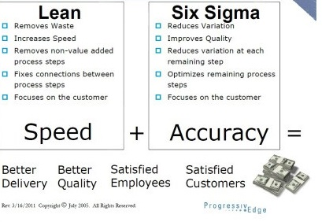

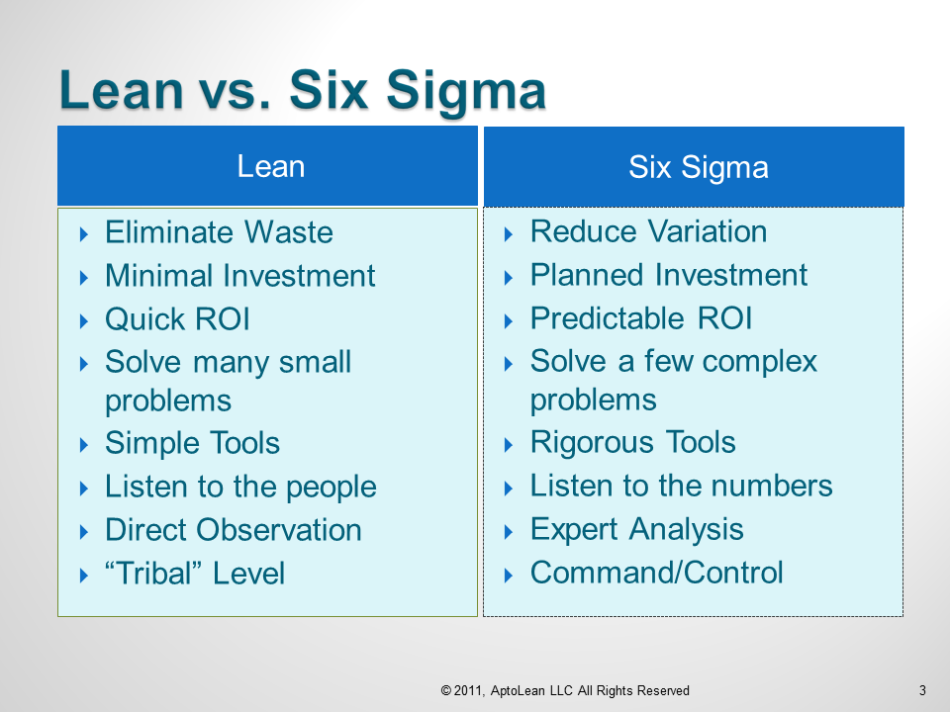

### Six sigma and TQM

* Six Sigma is more than just a process improvement program as it is based on concepts that focus on continuous quality improvements for achieving near perfection by restricting the number of possible defects to less than 3.4 defects per million. It is complementary to Statistical Process Control (SPC), which uses statistical methods for monitoring and controlling business processes. Although both SPC and TQM help in improving quality, they often reach a stage after which no further quality improvements can be made. Six Sigma, on the other hand, is different as it focuses on taking quality improvement processes to the next level.
* The basic difference between Six Sigma and TQM is the approach. While TQM views quality as conformance to internal requirements, Six Sigma focuses on improving quality by reducing the number of defects. The end result may be the same in both the concepts (i.e. producing better quality products). Six Sigma helps organizations in reducing operational costs by focusing on defect reduction, cycle time reduction, and cost savings. It is different from conventional cost cutting measures that may reduce value and quality. It focuses on identifying and eliminating costs that provide no value to customers such as costs incurred due to waste.
* TQM initiatives focus on improving individual operations within unrelated business processes whereas  [Six Sigma program](http://www.sixsigmaonline.org/) focus on improving all the operations within a single business process. Six Sigma projects require the skills of professionals that are certified as ‘black belts’ whereas TQM initiatives are usually a part-time activity that can be managed by non-dedicated managers.
* Six sigma is also different from TQM in that it is fact based and data driven, result oriented, providing quantifiable and measurable bottom-line results, linked to strategy and related to customer requirements. Although many tools and techniques used in Six Sigma may appear similar to TQM, they are often distinct as in Six Sigma, the focus is on the strategic and systematic application of the tools on targeted projects at the appropriate time

### Six sigma and TOC

* Limitations of TOC and Six Sigma:
* Six Sigma attempts to reduce variation in all the processes in order to achieve overall improvement in system. System interdependencies are not taken into account and processes are improved independently. As a result, there is plethora of potential projects (improvement opportunities) in any system improvement initiative and it can be difficult to identify which ones to tackle first.
* Additionally, the propensity to reduce variation in all the processes sometimes make it difficult to identify single or few processes of significant impact; ultimately escalating the budget and time for the overall improvement program.
* TOC provides good guideline to identify the constraint or bottleneck but its lack of statistical tools to quantitatively measure and analyze the performance of the process makes this methodology somewhat less effective.
* Harness the Synergy Between Six Sigma and TOC:
* [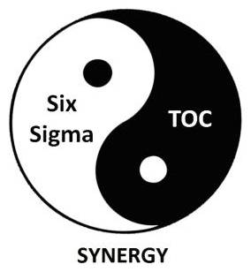](javascript:ShowLargerImageWindowName('AbishekSoni','/article_images/large/AbishekSoni.jpg'))After studying the above limitations it seems both the improvement methodologies are complementary to each other. And if used in conjunction significant amount of synergy can be derived from them. TOC can be used to identify the constraint (process of significant impact) while statistical tools of Six Sigma can be used to quantitatively measure and analysis process performance. In other words TOC will enable an organization to identify where to judiciously launch a Six Sigma based improvement project.
* Here are four areas where TOC and Six Sigma could be used in conjunction:
* ***Opportunity #1:Identify the significant opportunity***
* Start with first step of *TOC, identify the constraint* to discover the bottleneck process in the overall system. Once the process of significant impact is identified introduce Six Sigma.*DEFINE* phase of Six Sigma methodology will concentrate only on the identified constraint or bottleneck process (restricting the overall improvement scope, budget and time) and correspondingly determine the most significant CTQ. Use *MEASURE* phase tools to determine performance standard, collect process data and conduct measurement system analysis.
* The most significant improvement opportunity with well defined scope and performance standard is the final deliverable of this phase.
* ***Opportunity #2: Analyze the Problem***
* Use *ANALYZE* phase tools to establish capability of bottleneck process. Leverage tools such as ANOVA, Regression analysis, Pareto, Ishikawa diagram to identify the sources of variations and root cause of the problem. Complement analysis *with TOC step, identifying ways to exploit the constraint* or bottleneck process to its full capacity. This will ensure that existing capacity is utilized without any additional investment.
* ***Opportunity #3: Develop the Solution***
* Generate possible solutions for the problem using various techniques of *IMPROVE* phase such as DOE,poka yoke,pugh matrix,FMEA etc. Bolster the solution with *TOC step; subordinate all the other processes to exploited constraint*. This will ensure that all other processes of the system are aligned with solution identified. If sufficient investment is available proceed with *TOC step to elevate the constraint* i.e. remove the constraint of the system by increasing its capacity.
* ***Opportunity #4: Verify & Continuously Improve***
* Gather feedback on the performance of the new process using *CONTROL* phase tool control charts. Continue the pursuit of excellence and begin with *first step of TOC* to discover new constraint.

[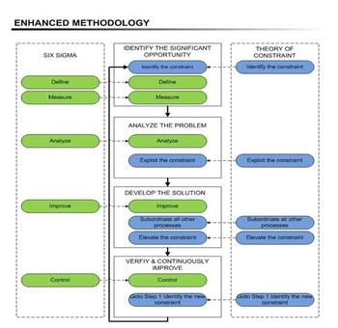](javascript:ShowLargerImageWindowName('ENHANCED_METHODOLOGY','/article_images/large/ENHANCED_METHODOLOGY.JPG'))

# Reference:

The_Six_Sigma_Handbook.pdf

How_Six_Sigma_Works.pdf

<http://www.businessballs.com/sixsigma.htm>

<http://www.isixsigma.com/new-to-six-sigma/history/history-six-sigma/>

<http://www.ge.com/sixsigma/keyelements.html>

<http://money.howstuffworks.com/six-sigma2.htm>

<http://money.howstuffworks.com/six-sigma1.htm>

<http://en.wikipedia.org/wiki/Six_Sigma>

<http://www.slideshare.net/BenchmarkSixSigma/six-sigma-in-various-industries>

<http://ucsandiegoextension.wordpress.com/2013/02/20/six-sigma-lean-bringing-speed-accuracy-to-business-processes/>

<http://www.sixsigmaonline.org/SSO_Brochure.pdf>

<http://www.aptoblog.com/2011/six-sigma-vs-lean-%E2%80%9Ctastes-great%E2%80%9D-or-%E2%80%9Cless-filling%E2%80%9D/08>

<http://www.sixsigmaonline.org/six-sigma-training-certification-information/articles/six-sigma-vs-total-quality-management.html>

<http://www.isixsigma.com/training/certification-articles/what-six-sigma-certification/>

<http://www.ehow.com/how_4815908_six-sigma-certified.html#ixzz2hIPERzFe>

<http://asq.org/learn-about-quality/six-sigma/overview/belts-executives-champions.html>

6sigma online: <http://www.sixsigmaonline.org/SSO_Brochure.pdf>

<http://www.slideshare.net/anandsubramaniam/dmaic-vs-dmadv>